**Python for Deep Learning**

**LAB 2**

**Lab ID 7**

Avinash Ganguri – 6

Sri Sai Nikhil Kantipudi – 10

Dileep Reddy Peddakam - 19

1. Using sequential model from keras, we have implemented the linear regression model in the boston house dataset.

b) Used different hyper parameters with learning rate as 0.01, and optimizers like adam, sigmoid and changed the batch size from 40 to 50, and activation functions like tanh and relu with softmax functions.

And trained the model,

a) The change in hyperparemeters can be noted in the log files and the loss curve and mse, mean squared error chosen as metrics.

The note of change in colors of the tensorboard can be observed with different timestamps.

1. Heart disease csv file is used for logistic regression here.
2. after normalizing data,

1. after changing the hyperparameters like optimizers, loss functions with different batch sizes and epochs and learning rate,

Before changing the hyperparameters,

After changing the hyperparameters the accuracy is,

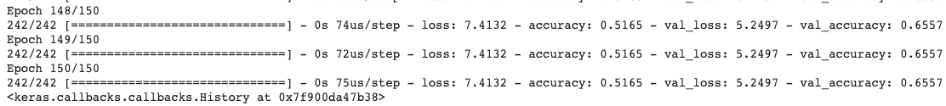

1. A screenshot of a social media post

   Description automatically generated
2. Ten different monkey species is taken as our dataset from Kaggle and implemented the image classification on it.

Label info is displayed,

Common monkey species,

Data is trained here,

Sample images are shown,

Defining the neural network model,

Using callback functions here,

Accuracy of our model,

Classification report,

1. Text classification is done through parsing and tokenization of phrases and sentimental analysis is done.

Here, we used the movie review dataset,

Data is split into training and testing datasets,

Train data is tokenized using 3000 max features,

Similarily,test data is tokenized using 5000 max features,

After the train and test data shape matches we use label encoder and train our model,

the accuracy of the model is,

1. Text classification is done through parsing and tokenization of phrases and sentimental analysis is done.

Here, we used the movie review dataset,

Train data is displayed,

Test data is displayed,

Train data is tokenized using 5000 max features,

Similarily, test data is tokenized using 2000 max features,

After the train and test data shape matches we use label encoder and train our model,

The accuracy for the model is,

1. The CNN Model for the 4th question after changing the hyperparameters,

After changing the hyperparameters such as,

learning rate to 0.01,

optimizers like adam and sgd,

epochs from 5 to 15,

batch size from 41 to 51,

activation functions such as tanh and relu

and loss function from binary_crossentropy to categorial_crossentropy

the accuracy is:

For the LSTM Model in the 5th question after changing the hyperparameters,

The hyperparameters are changed such as,

embedded dimensions to 50,

lstm_out as 50,

optimizers,

loss and activation functions,

epochs and batch sizes,

The model accuracy is:

LSTM Model is observed as best for text classification after the results.

1. Using Autoencoders for the MNIST data set,

Preprocessing the data such as normalizing and scaling the images,

Defining the model,

Encoding dimensions is set to 32

And the activation functions such as relu and sigmoid have been used,

Optimizer adadelta is used with binary_crossentropy as loss function.

Compiling the model with 5 epochs and 256 as batch size,

The input image is displayed,

